Introduction to LEX

Lex and YACC helps you write programs that transforms structured input. Lex generates C code for lexical analyzer whereas YACC generates Code for Syntax analyzer. Lexical analyzer is build using a tool called LEX. Input is given to LEX and lexical analyzer is generated.

Lex is a UNIX utility. It is a program generator designed for lexical processing of character input streams. Lex generates C code for lexical analyzer. It uses the patterns that match strings in the input and converts the strings to tokens. Lex helps you by taking a set of descriptions of possible tokens and producing a C routine, which we call a lexical analyzer. The token descriptions that Lex uses are known as regular expressions.
1.1 Steps in writing LEX Program:
1st step: Using gedit create a file with extension l. For example: prg1.l

2nd Step: lex prg1.l

3rd Step: cc lex.yy.c –ll

4th Step: ./a.out
1.2 Structure of LEX source program:

1stCol | 2ndCol |  | 3rdCol |  | 4thCol
 | DEFINITION SECTION
%%
 | RULE SECTION
%%
 | CODE SECTION

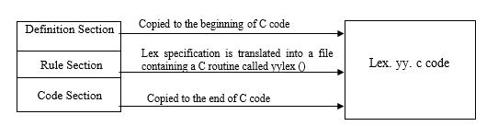

- is a delimiter to the mark the beginning of the Rule section. The second %% is optional, but the first is required to mark the beginning of the rules. The definitions and the code /subroutines are often omitted
Lex variables
 | yyin | Of the type FILE*. This points to the current file being parsed by the lexer.
 | yyout | Of the type FILE*. This points to the location where the output of the lexer will be
 |  | written. By default, both yyin and yyout point to standard input and output.
 | yytext | The text of the matched pattern is stored in this variable (char*).
 | yyleng | Gives the length of the matched pattern.
 | yylineno | Provides current line number information. (May or may not be supported by the
 |  | lexer.)
Lex functions
 | yylex() | The function that starts the analysis. It is automatically generated by Lex.
 | yywrap() | This function is called when end of file (or input) is encountered. If this function
 |  | returns 1, the parsing stops. So, this can be used to parse multiple files. Code can
 |  | be written in the third section, which will allow multiple files to be parsed. The
 |  | strategy is to make yyin file pointer (see the preceding table) point to a different
 |  | file until all the files are parsed. At the end, yywrap() can return 1 to indicate end
 |  | of parsing.
 | yyless(int n) | This function can be used to push back all but first ‘n’ characters of the read token.
 | yymore() | This function tells the lexer to append the next token to the current token.

1.3 Regular Expressions

It is used to describe the pattern. It is widely used to in lex. It uses meta language. The character used in this meta language are part of the standard ASCII character set. An expression is made up of symbols. Normal symbols are characters and numbers, but there are other symbols that have special meaning in Lex. The following two tables define some of the symbols used in Lex and give a few typical examples.

Character | Meaning
A-Z, 0-9, a-z | Characters and numbers that form part of the pattern.
. | Matches any character except \n.
- | Used to denote range. Example: A-Z implies all characters from A to Z.
[ ] | A character class. Matches any character in the brackets. If the first character is
 | ^ then it indicates a negation pattern. Example: [abC] matches either of a, b,
 | and C.

Character |  |  | Meaning
* | Match zero or more occurrences of the preceding pattern.
+ | Matches one or more occurrences of the preceding pattern.(no empty string)
 | Ex: [0-9]+ matches “1”,”111” or “123456” but not an empty string.
? | Matches zero or one occurrences of the preceding pattern.
 | Ex: -?[0-9]+ matches a signed number including an optional leading minus.
? | Matches zero or one occurrences of the preceding pattern.
 | Ex: -?[0-9]+ matches a signed number including an optional leading minus.
$ | Matches end of line as the last character of the pattern.
{ } | 1) Indicates how many times a pattern can be present. Example: A{1,3} implies
 | one to three occurrences of A may be present.
 | 2) If they contain name, they refer to a substitution by that name.
 | Ex: {digit}
\ | Used to escape meta characters. Also used to remove the special meaning of
 | characters as defined in this table.
 | Ex: \n is a newline character, while “\*” is a literal asterisk.
^ | Negation.
| | Matches either the preceding regular expression or the following regular
 | expression. Ex: cow|sheep|pig matches any of the three words.
"< symbols>" | Literal meanings of characters. Meta characters hold.
/ | Look ahead. Matches the preceding pattern only if followed by the succeeding
 | expression. Example: A0/1 matches A0 only if A01 is the input.
( ) | Groups a series of regular expressions together into a new regular expression.
 | Ex: (01) represents the character sequence 01. Parentheses are useful when
 | building up complex patterns with *,+ and |
Examples of regular expressions
Regular |  |  | Meaning
expression
joke[rs] |  |  |  | Matches either jokes or joker.
A{1,2}shis+ |  |  |  | Matches AAshis, Ashis, AAshi, Ashi.
(A[b-e])+ |  |  |  | Matches zero or one occurrences of A followed by any character from b to e.
[0-9] |  |  |  | 0 or 1 or 2 or………9
[0-9]+ |  |  |  | 1 or 111 or 12345 or …At least one occurrence of preceding exp
[0-9]* |  |  |  | Empty string (no digits at all) or one or more occurrence.
-?[0-9]+ |  |  |  | -1 or +1 or +2 …..
[0.9]*\.[0.9]+ |  |  |  | 0.0,4.5 or .31415 But won’t match 0 or 2

Examples of token declarations

Token | Associated expression | Meaning
number | ([0-9])+ | 1 or more occurrences of a digit
chars | [A-Za-z] | Any character
blank | " " | A blank space
word | (chars)+ | 1 or more occurrences of chars
variable | (chars)+(number)*(chars)*( number)*

2. Introduction to YACC
YACC provides a general tool for imposing structure on the input to a computer program. The input specification is a collection of grammar rules. Each rule describes an allowable structure and gives it a name. YACC prepares a specification of the input process. YACC generates a function to control the input process. This function is called a parser.

The name is an acronym for “Yet Another Compiler Compiler”. YACC generates the code for the parser in the C programming language. YACC was developed at AT& T for the Unix operating system. YACC has also been rewritten for other languages, including Java, Ada.

The function parser calls the lexical analyzer to pick up the tokens from the input stream. These tokens are organized according to the input structure rules .The input structure rule is called as grammar. When one of the rule is recognized, then user code supplied for this rule ( user code is action) is invoked. Actions have the ability to return values and makes use of the values of other actions.

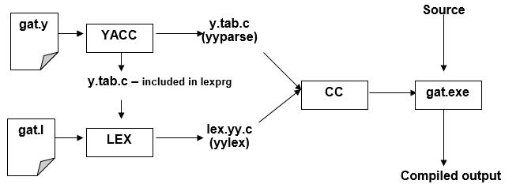

2.1 Steps in writing YACC Program:
1st step: Usinggedit editor create a file with extension y. For example: prg1.y

2nd Step: YACC –d prg1.y

3rd Step: lex prg1.l

4th Step: cc y.tab.c lex.yy.c -ll

5th Step: /a.out
When we run YACC, it generates a parser in file y.tab.c and also creates an include file y.tab.h.

To obtain tokens, YACC calls yylex. Function yylex has a return type of int, and returns the token.

Values associated with the token are returned by lex in variable yylval.

2.2 Structure of YACC source program:
Basic Specification:
Every YACC specification file consists of three sections. The declarations, Rules (of grammars), programs. The sections are separated by double percent “%%” marks. The % is generally used in YACC specification as an escape character.
The general format for the YACC file is very similar to that of the Lex file.

1stCol | 2ndCol | 3rdCol | 4thCol
 | DEFINITION SECTION
%%
 | RULE SECTION
%%
 | CODE SECTION

%% is a delimiter to the mark the beginning of the Rule section.

Definition Section
%union | It defines the Stack type for the Parser. It is a union of various datas/structures/
 | objects
%token | These are the terminals returned by the yylex function to the YACC. A token can
 | also have type associated with it for good type checking and syntax directed
 | translation. A type of a token can be specified as %token <stack
 | member>tokenName.
 | Ex: | %token NAME NUMBER
%type | The type of a non-terminal symbol in the Grammar rule can be specified with
 | this.The format is %type <stack member>non-terminal.
%noassoc | Specifies that there is no associatively of a terminal symbol.
%left | Specifies the left associatively of a Terminal Symbol
%right | Specifies the right associatively of a Terminal Symbol.
%start | Specifies the L.H.S non-terminal symbol of a production rule which should be
 | taken as the starting point of the grammar rules.
%prec | Changes the precedence level associated with a particular rule to that of the
 | following token name or literal

Rules Section
The rules section simply consists of a list of grammar rules. A grammar rule has the form:
A: BODY
A represents a nonterminal name, the colon and the semicolon are YACC punctuation and BODY represents names and literals. The names used in the body of a grammar rule may represent tokens or nonterminal symbols. The literal consists of a character enclosed in single quotes.
Names representing tokens must be declared as follows in the declaration sections:

%token name1 name2…
Every name not defined in the declarations section is assumed to represent a non-terminal symbol. Every non-terminal symbol must appear on the left side of at least one rule. Of all the no terminal symbols, one, called the start symbol has a particular importance. The parser is designed to recognize the start symbol. By default, the start symbol is taken to be the left hand side of the first grammar rule in the rules section.

With each grammar rule, the user may associate actions to be. These actions may return values and may obtain the values returned by the previous actions. Lexical analyzer can return values for tokens, if desired. An action is an arbitrary C statement. Actions are enclosed in curly braces.
List of Experiments:
- Write a LEX program to recognize valid arithmetic expressions. Identifiers in the expression could be only integers and operators could be + and *. Count the identifiers & operators present and print them separately.
Input: (a*b) Expected output : Valid arithmetic expression
- Write a LEX program to recognize whether a given sentence is simple or compound
Input : My name is XYZ Expected output : Simple
- Write a LEX program to eliminate comment lines in a C program and copy the resulting program into a separate file - > Exercise
- Write a LEX program to count the number of characters, words, spaces and lines in each input file.
- Write YACC program to evaluate arithmetic expression involving operators: +, -, *, and /.
- Write a program using LEX/YAAC tools to recognize valid identifier, operators and keywords in the given text (C program) file and print the same.
- Implement a program using LEX/YAAC tools to recognize a valid identifier in a given ‘C’ file.
- Implement a program using LEX/YACC tool to recognize all strings ending with b preceded by n a’s using the grammar a ^{n} b (note: input n value).

1. Write a LEX program to recognize valid arithmetic expressions. Identifiers in the expression could be only integers and operators could be + and *. Count the identifiers & operators present and print them separately.
Input: (a*b) Expected output : Valid arithmetic expression
Program 1a:
1a.l (Lex Part)
%{
#include<stdio.h>
int oc=0,ic=0,pc=0;
%}
%%
[a-z|A-Z] {++ic;} or [_]* [a-z|A-Z|0-9] {++operand;} [\+|\-|\*|\/|\%] {++oc;} or [_]* [a-z|A-Z|0-9]+[ [\+|\-|\*|\/|\%][_]* [a-z|A-Z|0-9]+([\+|\-|\*|\/|\%][_]* [a-z|A-Z|0-9]+)* {++flag;} input: _a+_b+c , a+b*c-d
[0-9]+ {++ic;}
[+|\-|*|/]+ {++oc;}
[(] {++pc;}
[)] {--pc;}
%%
void main(int argc,char *argv[])
{
yyin = fopen(argv[1],"r");
yylex();
if(ic-oc==1 && pc==0) if(flag==1) printf(“valid”) else printf(“invalid”);
{
printf("valid identifier\n");
printf("operand=%d and operator=%d\n",ic,oc);
}
else
{
printf("invalid");
}
}
int yywrap()
{
return -1;
}

Output
$lex 1a.l
$cc lex.yy.c
$./a.out
enter arithmtic expression : 5 + ab – 69 * 50
5 is a operand
+ is a operator
ab is a operand
– is a operator
69 is a operand
* is a operator
50 is a operand
valid expression
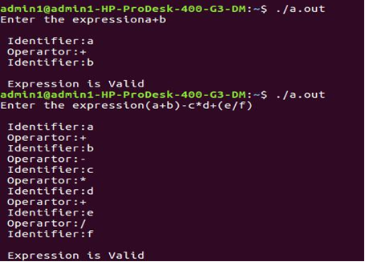

2.a) Write a LEX program to eliminate comment lines in a C program and copy the
resulting program into a separate file.
Program 6a:
6a.l(Lex Part)
%{
#include<stdio.h>
int cl=0;
%}
%%
("/*"[^*/]*"*/")|"//"(.)* {++cl;fprintf(yyout," ");}
.* {fprintf(yyout,yytext);}

%%
void main(int argc,char *argv[])
{
yyin = fopen(argv[1],"r");
yyout = fopen(argv[2],"w");
yylex();
printf("The number of comment lines are %d\n",cl);

}
int yywrap()
{
return -1;
}
Output
$lex 6a.l
$cc lex.yy.c
$./a.out in.c out.c
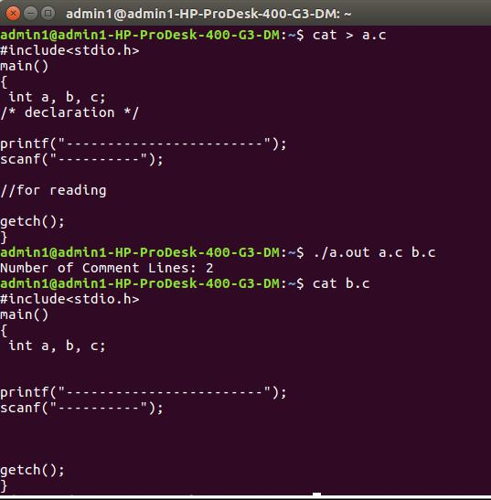
no of comments is 4

3. Program to count the number of characters, words, spaces and lines in a given input file.
%{
int sc=0,wc=0,cc=0,lc=0;
%}
%%
[ ]+ {++sc;}
[a-zA-Z0-9]+ {++wc;cc=cc+yyleng;}
[/n]+ {lc++;}
. ;
%%
int main(int argc, char *argv[])
{
yyin=fopen(argv[1],"r");
yylex();
printf("spaces= %d\n",sc);
printf("characters= %d\n",cc);
printf("lines= %d\n",lc);
printf("words= %d\n",wc);
}
int yywrap()
{
return -1;
}

Output
$lex 1a.l
$cc lex.yy.c
$./a.out in.txt

spaces = 9
characters= 30
lines= 3
words= 6

4. Program to recognize whether a given sentence is simple or compound.
space [ \t]+
word [a-zA-Z0-9]+
both {word}|{space}
%{
int flag=0;
%}

(.)* (“and”|”but”|”or”)(.)* compound
(.)* (“^and”|”^but”|”^or”)(.)* simple

%%
{both}{space}"and"{space}{both} {flag=1;}
{both}{space}"but"{space}{both} {flag=1;}
{both}{space}"or"{space}{both} {flag=1;}
%%
int main()
{
printf("enter the sentence\n");
yylex();
if(flag==0)
printf("simple sentence\n");
else
printf("compound sentence\n");
return 0;
}
int yywrap()
{
return -1;
}

Output
$lex 2b.l
$cc lex.yy.c
$./a.out
enter the sentence
This is vvce and I am a student of ISE

